ITC306
Assessment 1 Template: Project Charter and Plan

Instructions: Replace all [Enter...] placeholders with your content. Remove guidance text before submission. Keep the Project Charter to max 2 pages and the Project Plan to max 1 page (excluding evidence).
Field | Your entry
Project ID / Project Name | 2026-6 – AI-Powered Cyber Phishing Simulator + Training Portal
Client / Sponsor | CSU
Team name | CyberShield
Team leader | Abdullah Al Numan
Deputy team leader | Md. Rifat al Mortoza
Team members | Samiur Rahman
Submission date | 30th March 2026
Version | 1.00

1. Project Charter (max 2 pages)

1.1 Problem / opportunity statement

CSU students and staff are increasingly exposed to phishing attacks, yet current training approaches are mostly theoretical and lack practical engagement. This results in low awareness and higher risk of security breaches. With phishing attacks becoming more sophisticated and frequent, there is an urgent need for an interactive, hands-on training solution. A simulated phishing environment with real-time feedback will improve user awareness and reduce cybersecurity risks effectively.

1.2 Objectives and success criteria (3-6)
List 3-6 objectives. Each objective must include a measurable success indicator.
Objectives table
Objective | Success measure (how you will know it is achieved)
Build a secure web portal for phishing simulations | System supports ≥10 concurrent users completing scenarios successfully
Record and track user performance | Admin dashboard accurately shows responses and progress
Provide AI or rule-based phishing scenario generation | Each user experiences ≥5 unique scenario types per session
Deliver admin reporting dashboard | Dashboard displays ≥3 performance metrics (accuracy, completion rate, improvement)
Ensure ethical compliance | 0 real emails sent; fully controlled lab simulation
Improve user awareness | Users score ≥30% improvement between pre and post assessment

1.3 Stakeholders and roles
Stakeholders table
Stakeholder | Role (care/decide/use/approve) | Responsibilities / interests | Contact / channel
CSU/Project Sponsor | Approve/Decide | Sets project expectations, reviews progress, and approves the final solution against client needs | Email / Project meetings
Jason Howarth | Approve/Care | Primary client contact; provides requirements, feedback, and approval of the simulator and training portal features | Teams / Email
Project Team | Decide/ Build | Design, develop, test, and document the phishing simulator, training workflows, admin page, and reporting functions | Teams / GitHub
System Administrator | Care / Use | Monitors user completion, reviews performance data, and tracks improvement through the admin portal | Web admin portal / Email
End users (Students, staff or demo users) | Use / Care | Complete phishing scenarios, make decisions in the simulator, and receive training feedback to improve cyber awareness | Web Portal/ Login systems
Security/Privacy Reviewer | Care/Approve | Ensures the system stays safe and ethical, avoids real phishing activity, and follows security and privacy constraints | Review Meetings/ Documentation

1.4 Scope boundaries (current)
Be explicit. Clear in-scope / out-of-scope boundaries help prevent scope creep.
Scope boundaries
In scope | Out of scope
Web portal development (Python/Flask + frontend) | Sending real phishing emails
User login/authentication | Mobile app version
AI or rule-based phishing scenario generator | Integration with corporate email systems
Admin dashboard & reporting | Paid third-party phishing services
Logging & analytics | Network penetration testing

1.5 Constraints and assumptions
Constraints and assumptions
Item | Type (Constraint / Assumption) | Implication for approach / feasibility
Limited project timeline (semester duration) | Constraint | Features must focus on a working prototype rather than a full production system
No real phishing emails allowed (ethical requirement) | Constraint | The system will simulate phishing scenarios only within a controlled training portal
Limited budget / no paid services | Constraint | Only free or open-source tools and frameworks will be used
Students have basic web development skills | Assumption | The system can be built using simple technologies like Python/Flask and basic frontend tools
Access to development tools (VS Code, GitHub, MySQL) | Assumption | Development, testing, and version control can be managed using these tools
Privacy and security compliance | Constraint | No real personal or corporate data will be used; only sample users or dummy accounts
Internet and local hosting availability | Assumption | The training portal can be tested using a local server or university lab environment
AI or rule-based scenario generator available | Assumption | Phishing examples can be generated using predefined templates or simple AI assistance

1.6 Solution context (project type)
1.6 Solution context (project type)

Software project product vision (if applicable)
For: CSU students and staff (end users) and system administrators (admin users)
The solution: A web-based phishing simulation and training portal that presents realistic phishing scenarios, captures user decisions, and provides immediate feedback and performance tracking.
Provides: Improved phishing awareness, measurable learning outcomes, and reduced cybersecurity risk through safe, controlled training simulations.

Software project product vision (if applicable)

1.7 High-level deliverables (4-8)
Deliverables
Deliverable | Description | Evidence of completion
Web-based phishing simulator | Functional portal with interactive phishing scenarios | Working demo + screenshots
User authentication system | Secure login/logout system for users | Tested login system + logs
Scenario generation module | AI/rule-based phishing scenario generator | Sample generated scenarios
Admin dashboard | Displays user performance and analytics | Dashboard screenshots + demo
Reporting system | Tracks progress and improvement over time | Exported reports/graphs
Training feedback system | Provides instant feedback after each scenario | UI screenshots + user flow
Testing and validation report | Testing results for functionality and usability | Test cases + results
Project documentation | Technical and user documentation | Final report + GitHub repo

1.8 Definition of success (1-2 lines)
A usable and secure phishing simulation system that demonstrates measurable improvement in user awareness, provides clear performance insights to administrators, and meets all ethical and functional requirements defined by the client.

2. Project Plan (max 1 page)
2.1 Main milestones (phase gates, not feature lists)
Milestone / phase gate | Target date | Deliverable/decision | Owner | Success evidence
Project initiation complete | Week 2 | Approved project charter | Rifat | Submitted document
Design approval | Week 4 | System architecture + UI design | Abdullah | Design diagrams
Prototype development | Week 6 | Working basic simulator | Dilraj | Demo prototype
Mid-project review | Week 8 | Feedback incorporated | Tanmeet | Updated system
Final system completion | Week 10 | Fully functional system | Team | Final demo
Submission & presentation | Week 12 | Final deliverables submitted | Team | Submission confirmation

2.2 Work breakdown summary (major work streams)
Work stream | Description | Owner | Notes
Project management | Planning, tracking, coordination | Rifat | Oversees progress
Backend development | Flask server, database, logic | Tanmeet | Core system
Frontend development | UI/UX design and implementation | Abdullah | User interface
Scenario design | Phishing content creation | Tanmeet | Training quality
Testing & QA | Testing functionality and usability | Abdullah | Continuous testing
Documentation | Reports and technical docs | Dilraj | Final submission

2.3 Schedule snapshot (key dates only)
Week | Key date | Milestone | Notes
Week 2 | Charter submission | Project initiation | Assignment 1
Week 4 | Design ready | Architecture finalised | Internal review
Week 6 | Prototype ready | Core system working | Demo
Week 8 | Mid review | Improvements applied | Feedback stage
Week 10 | Final build | Complete system | Testing done
Week 12 | Submission | Final delivery | Assessment
2.4 Top 5 risks and mitigations
Risk | Likelihood | Impact | Mitigation action | Owner
Limited time | High | High | Prioritise core features only | Rifat
Technical skill gaps | Medium | High | Use simple tools + online resources | Abdullah
Integration issues | Medium | Medium | Regular testing and debugging | Dilraj
Poor team coordination | Medium | High | Weekly meetings + task tracking | Rifat
Ethical/security issues | Low | High | Use simulated data only | Tanmeet

2.5 Communication cadence
Meeting | Purpose | Attendees | Frequency | Output | Tool
Weekly team meeting | Progress tracking | All members | Weekly | Meeting minutes | Teams
Client check-in | Feedback and approval | Leader + client | Bi-weekly | Feedback notes | Email
Daily quick sync | Task updates | Team | As needed | Task updates | WhatsApp
Sprint review | Demonstrate progress | Team | Fortnightly | Demo | Teams
Documentation review | Quality check | Team | Before submission | Final edits | Google Docs

2.6 Change control approach (1-2 sentences)

Any changes to scope or requirements will be proposed during team meetings, reviewed for feasibility and impact, and approved by the team leader and client before implementation.
3. Workspace and collaboration evidence (max 2 pages OR links + screenshots)
For: CSU students and staff (end users) and system administrators
The solution: A web-based phishing simulation and training portal that presents realistic phishing scenarios, captures user decisions, and provides immediate feedback and performance tracking
Provides: Improved phishing awareness, measurable learning outcomes, and reduced cybersecurity risks through safe and controlled simulations
Workspace evidence links
Evidence item | Link / location | Screenshot ref | Notes
ProjectLibre | [Insert ProjectLibre link] | 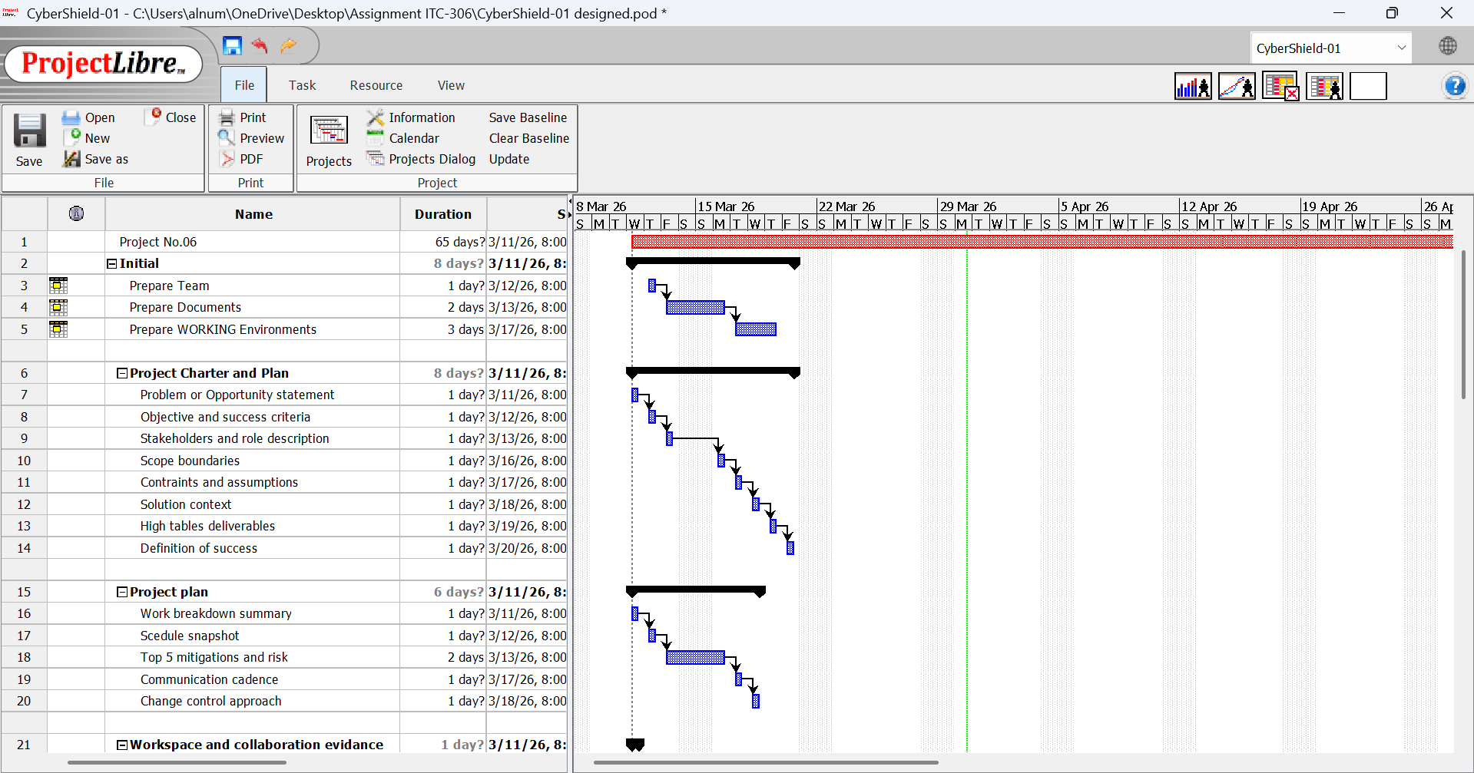 | Code and version control
Whatsapp | [Insert Teams link] | SS3 | Communication
Google Drive | [Insert link] | 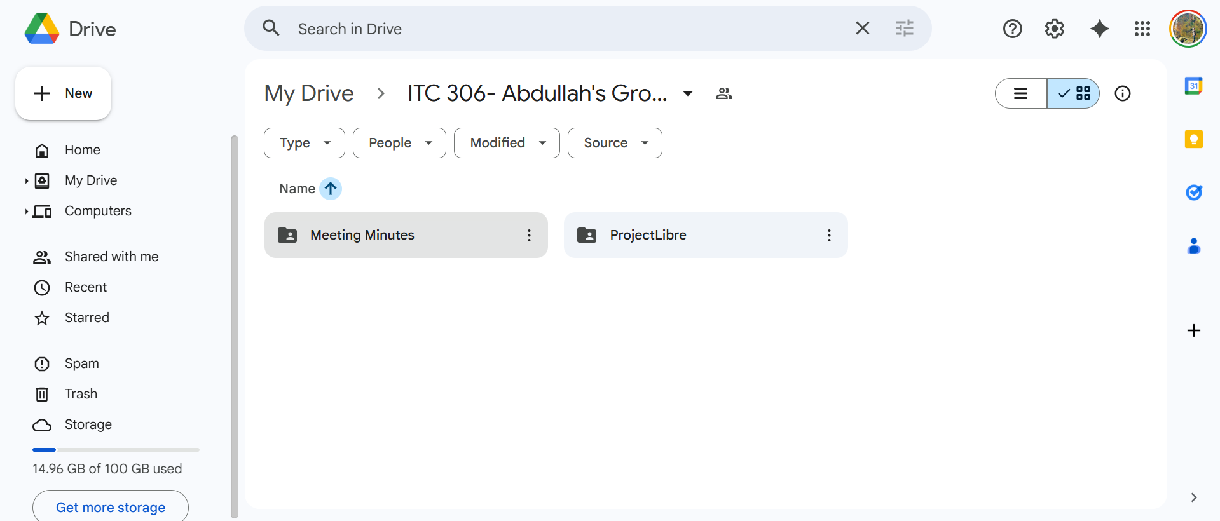 | Documents storage
Meeting minutes | [Insert link] | 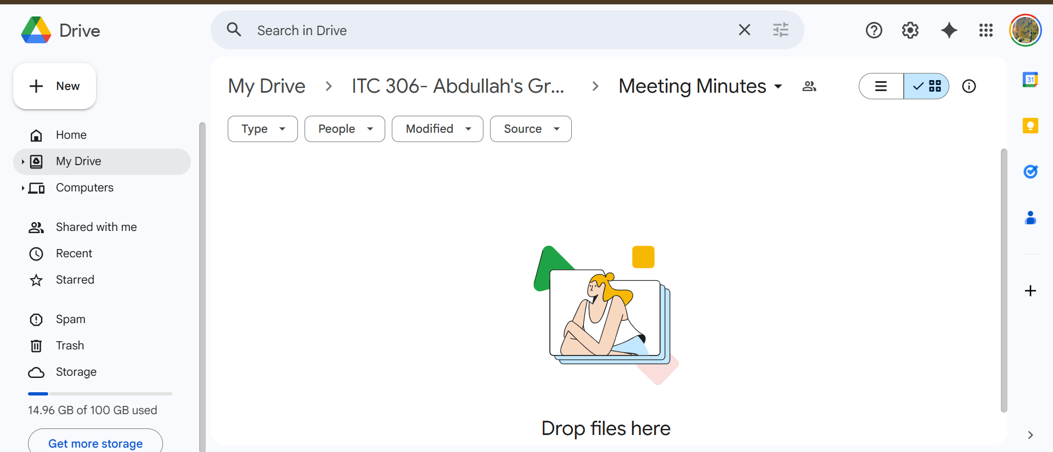 | Weekly records
Folder structure | [Insert link] | 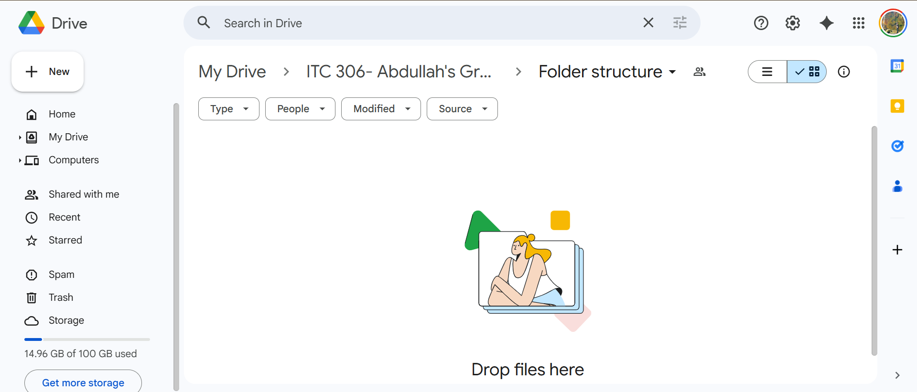 | Organized files
Evidence  link | [Insert link] | 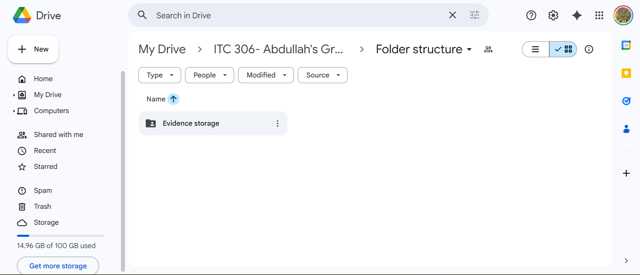  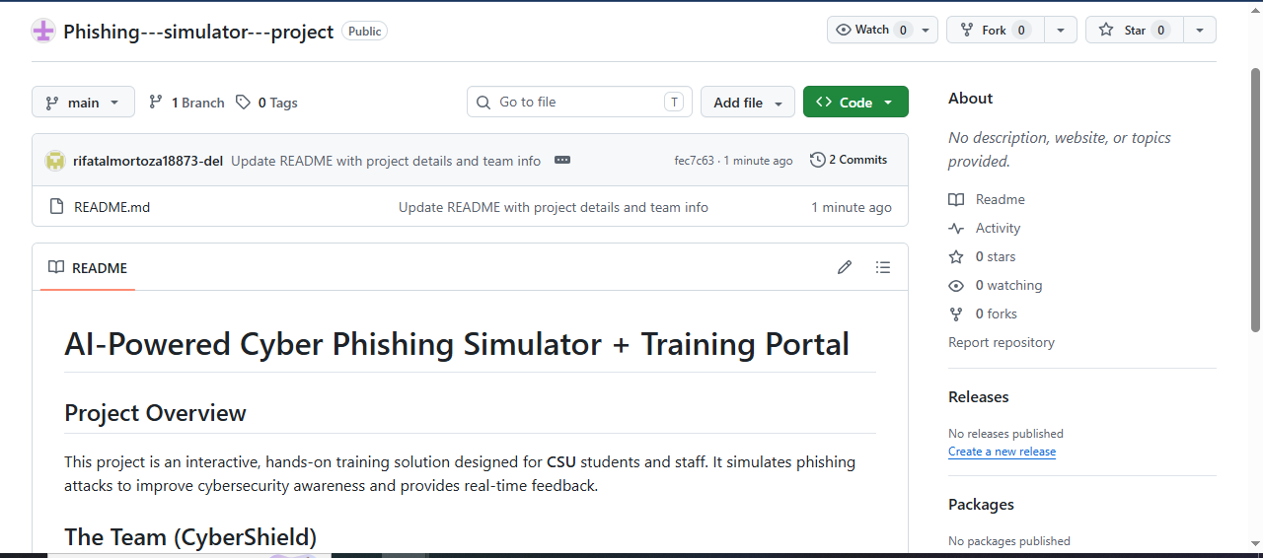  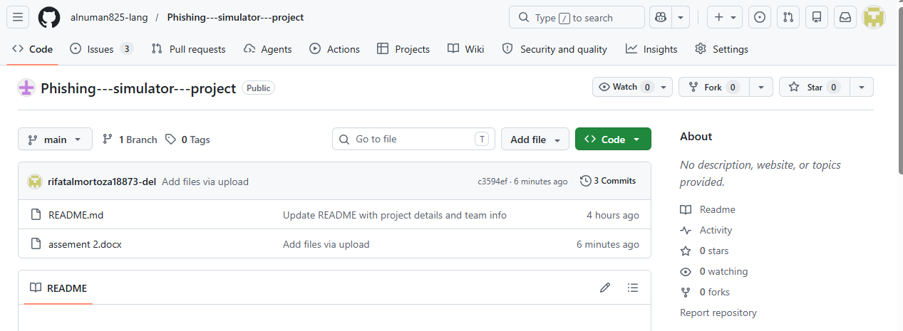  https://github.com/alnuman825-lang/Phishing---simulator---project/tree/main | Logs/screenshots

Evidence items to cover: PM tool/board setup; repository/artefact space; onboarding (members added, roles set); first tasks; first minutes; evidence trail location.

Submission checklist
- All placeholders replaced; guidance removed.
- Project Charter within max 2 pages; Project Plan within max 1 page (excluding evidence section).
- Milestones are phase gates (deliverables/decisions), not feature lists.
- Risks are project-specific with clear owners and mitigations.
- Links/screenshots show board, repo, artefact structure, onboarding and minutes.

